# Assignment_3_数据库

## 7.30:

* a
* 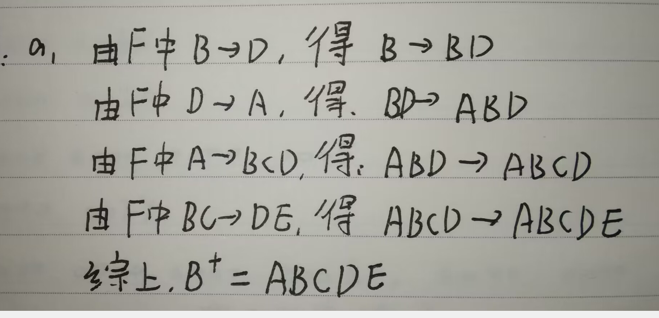
* b
* 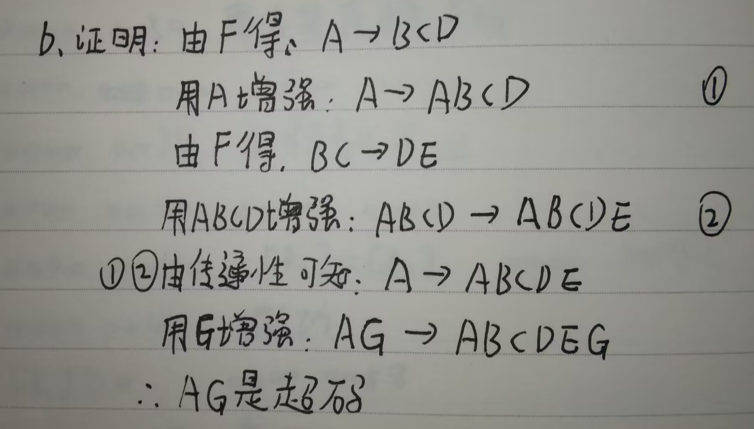
* c
* 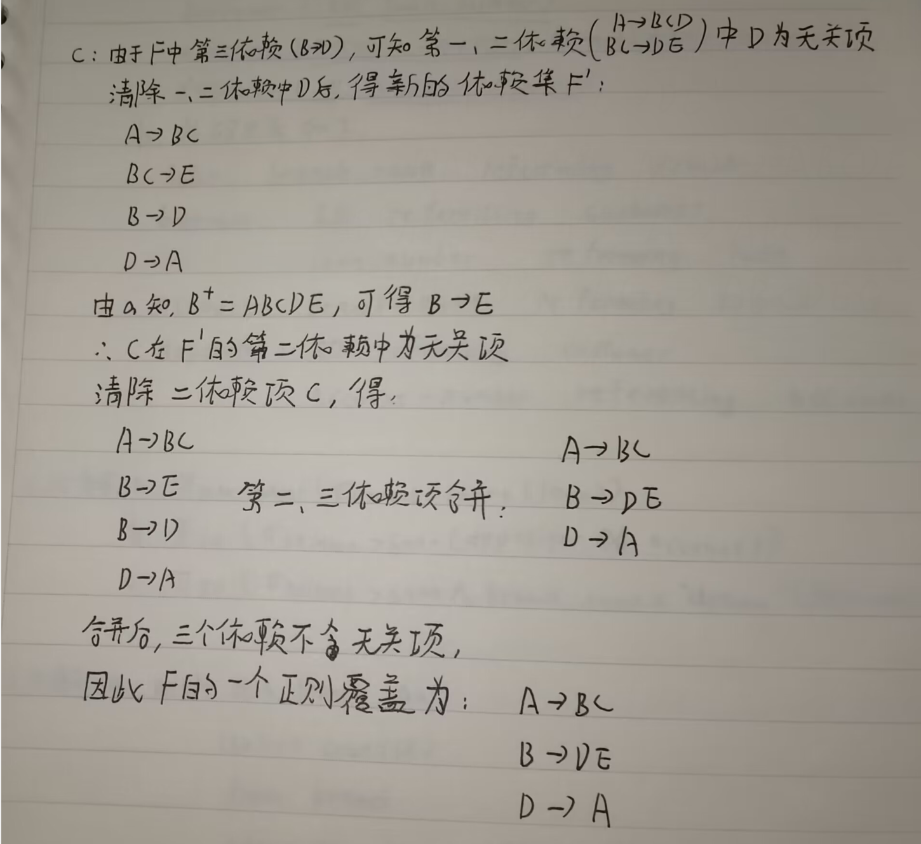
* d
* 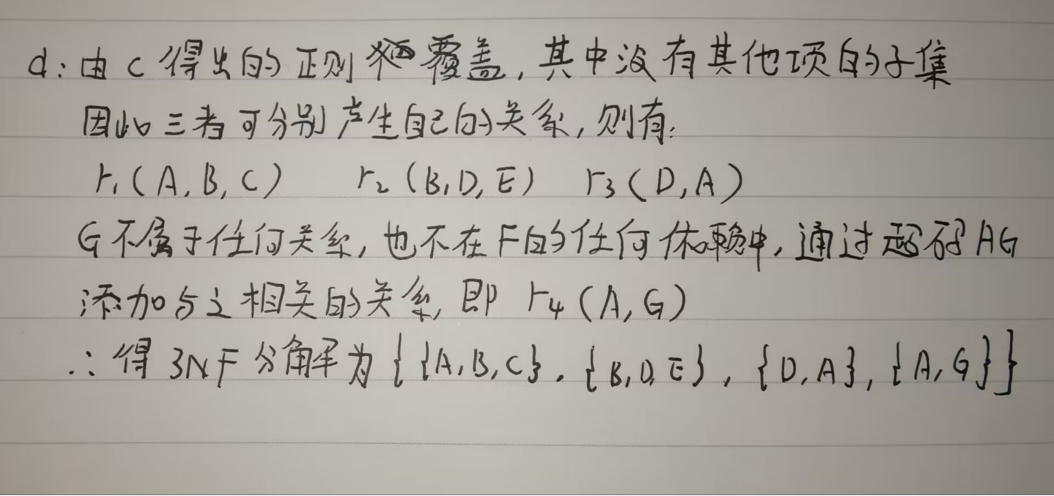
* e
* 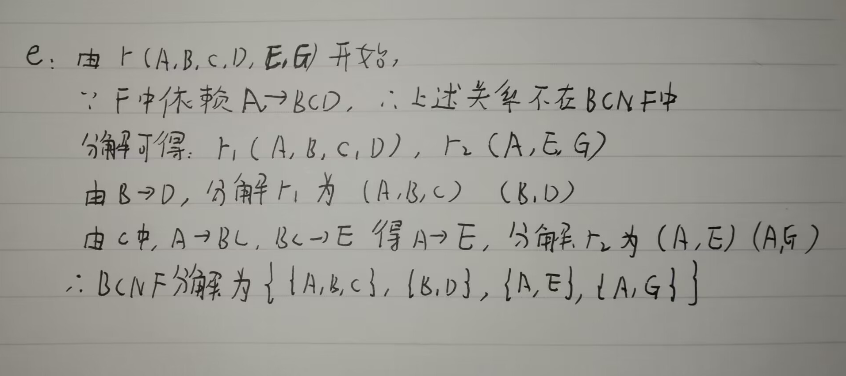

## 7.34:

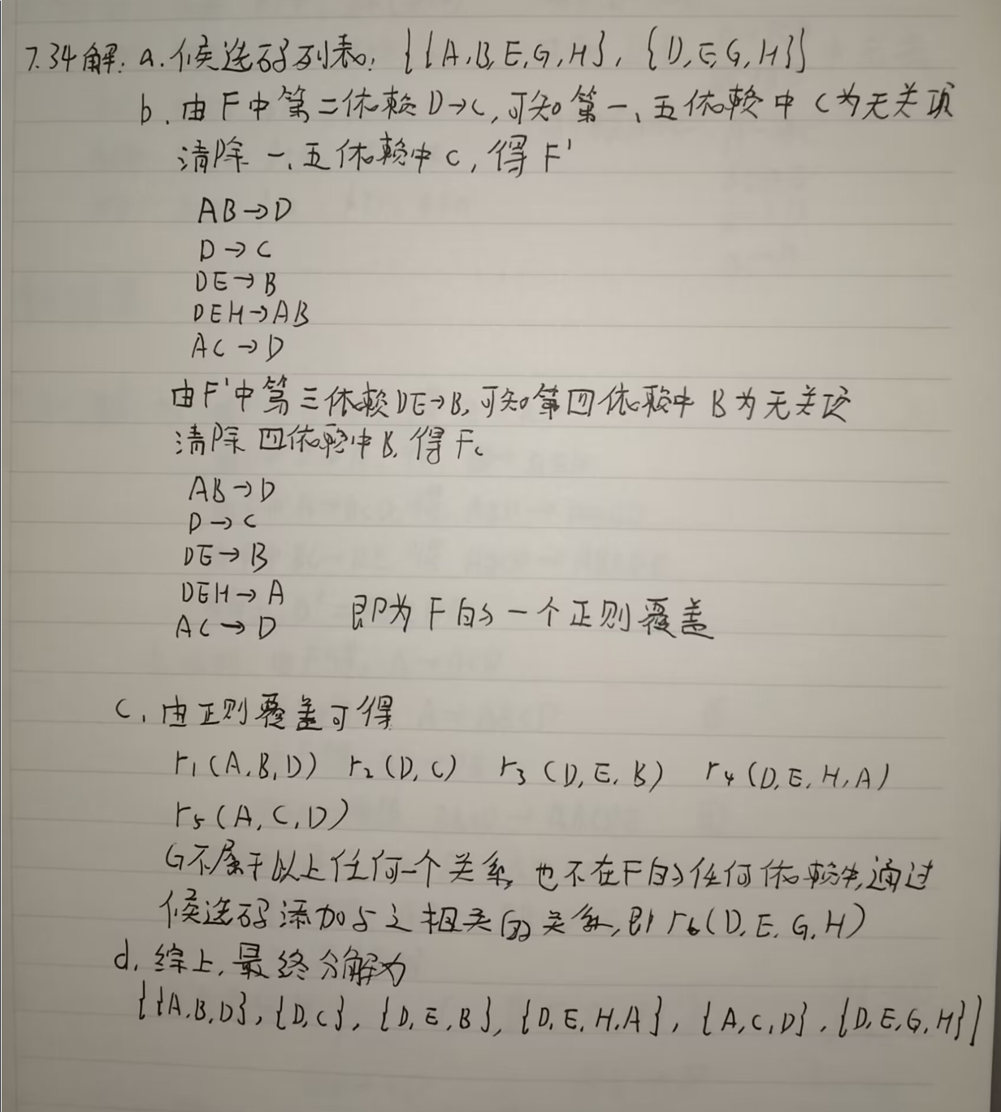

## 8.10:

Emp = (emp_id, ename)

Children = (child_id, name, birthday)

EmpChild = (emp_id, child_id)

Skills = (type)

Exams = (year, city)

SkillExams = (type,year, city)

SkillExamsEmp = (emp_id,type,year, city)

## 11.10:

由题意得：

* 50% 的总交易购买了牛仔裤
* 33.33% 的总交易购买了T恤衫
* 50% 的牛仔裤交易中购买了T恤衫

可得：

* 25%的总交易既购买了牛仔裤，又购买了T恤衫

关联规则有：

1. **牛仔裤 -> T恤衫**
   * **支持度**: 25%
 $$support\left(牛仔裤+T恤衫\right)=25\%$$  * **置信度**: 50%
$$confidence\left(牛仔裤→T恤衫\right)=\frac{25\%}{50\%}=50\%$$

2. **T恤衫 -> 牛仔裤**
   * **支持度**: 25%
 $$support\left(牛仔裤+T恤衫\right)=25\%$$  * **置信度**: 75%

$$confidence\left(T恤衫→牛仔裤\right)=\frac{25\%}{33.33\%}=75\%$$